Greening the Grid photo details

Parent Site:
Homepage
Slideshow images:
- 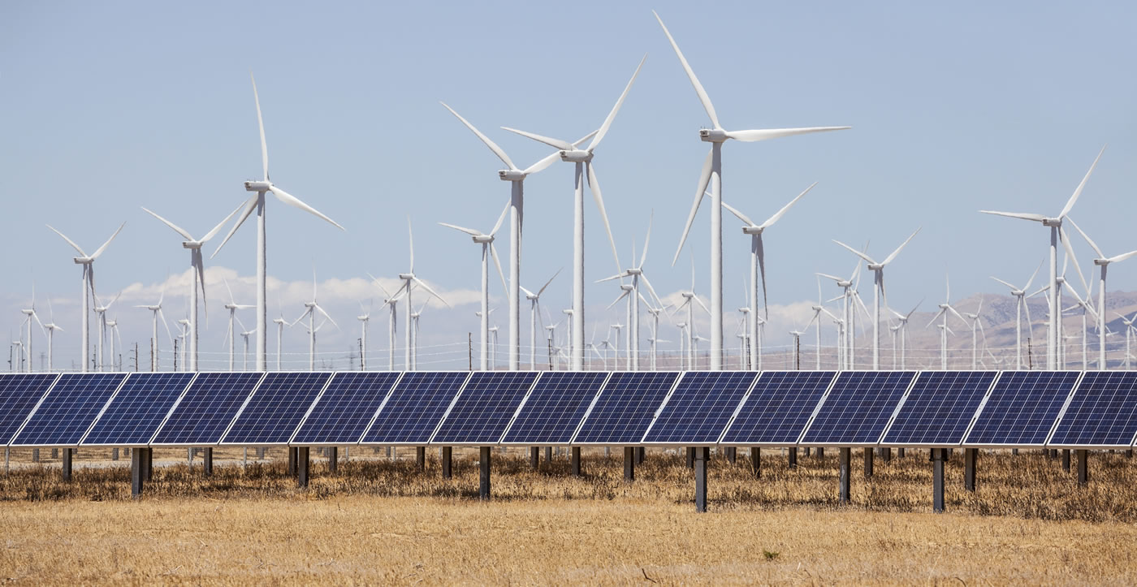
- 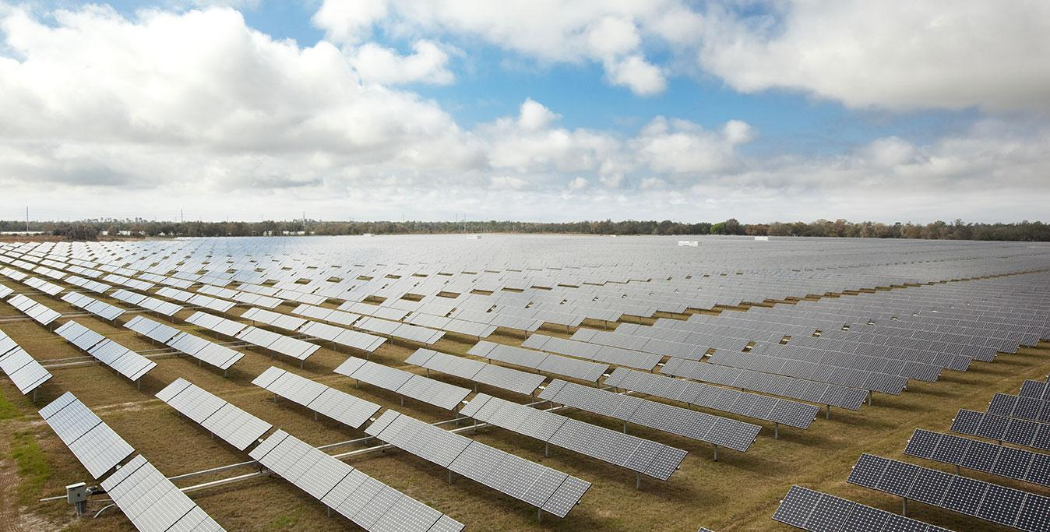
- 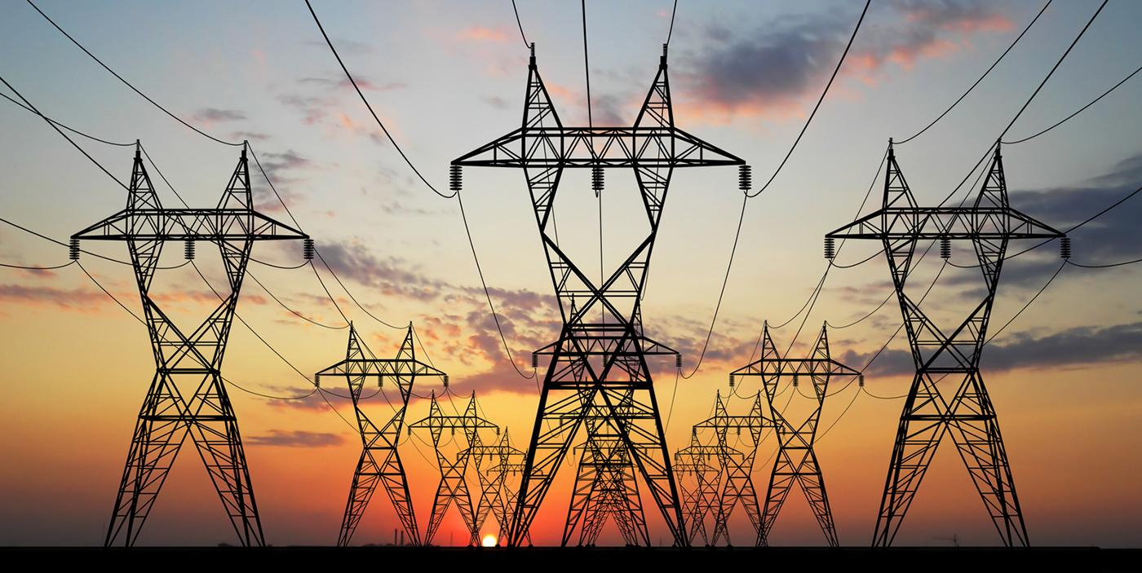

News Image
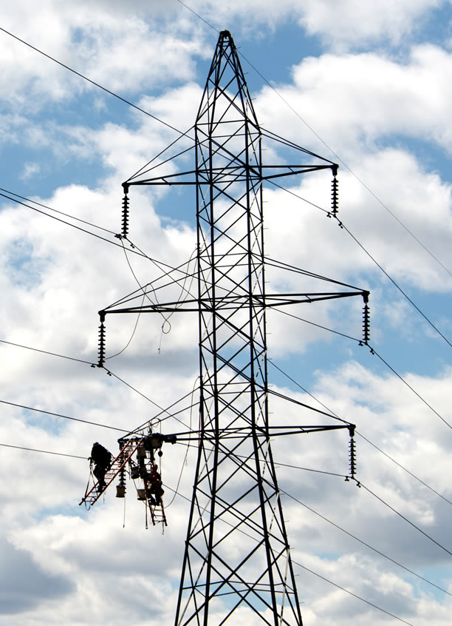

Source: Photo by American Public Power Association on Unsplash

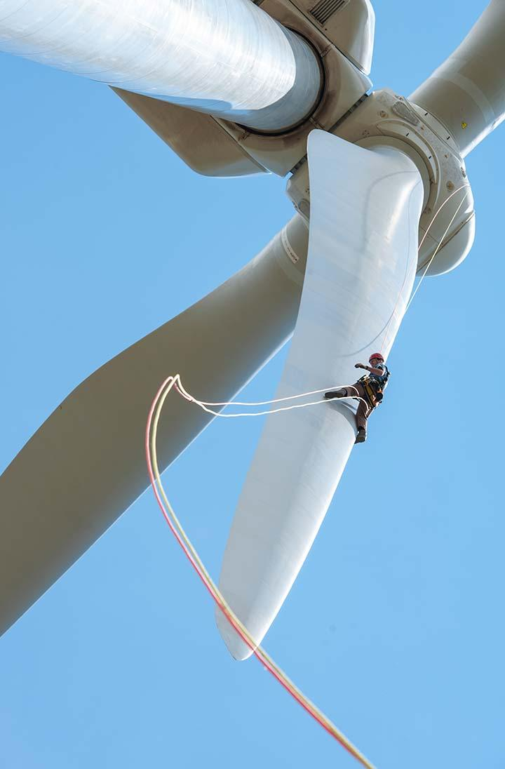
Credit: Dennis Schroeder, NREL
Source: NREL Instagram
https://www.instagram.com/p/BjnNfvxFl7T/?taken-by=nationalrenewableenergylab

About
http://greeningthegrid.org/about
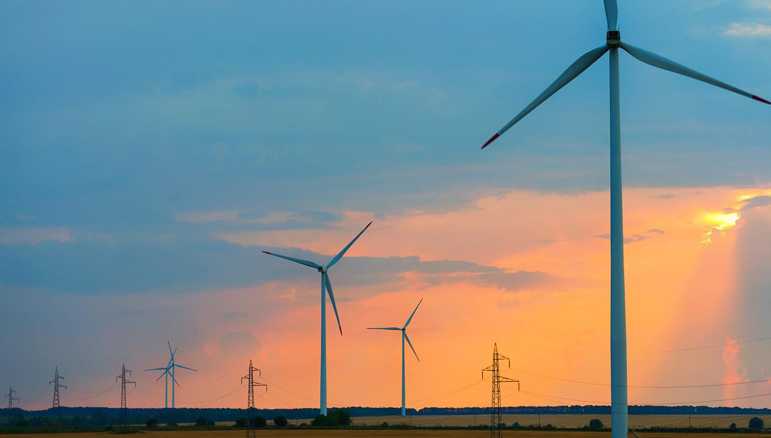
Title: Anypage_REZ Toolkit_iStock-187087247.jpg
Credit: iStock
Source: Photo provided by client (DropBox)

Ask an Expert
http://greeningthegrid.org/ask-an-expert
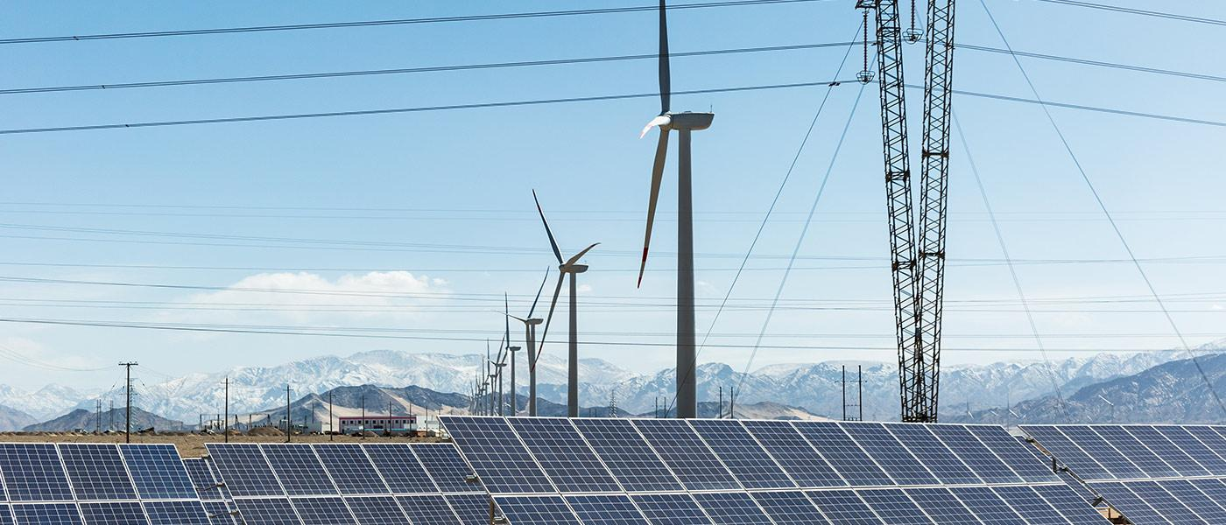
Title: 3_REZ Topics_REZ Toolkit_iStock-672741882.jpg
Credit: iStock
Source: Photo provided by client (DropBox)

Where We Work
http://greeningthegrid.org/where-we-work
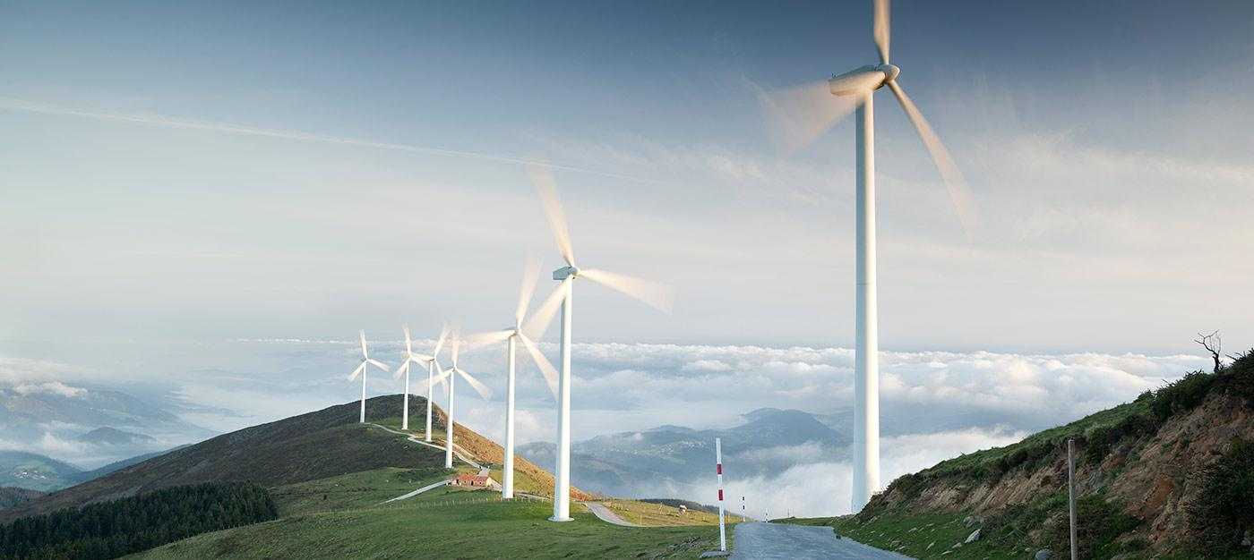
Title: 5_Trainings_REZ Toolkit_iStock-157588110.jpg
Credit: iStock
Source: Photo provided by client (DropBox)

Countries
Ghana -

India - https://www.nrel.gov/workingwithus/usaid.html
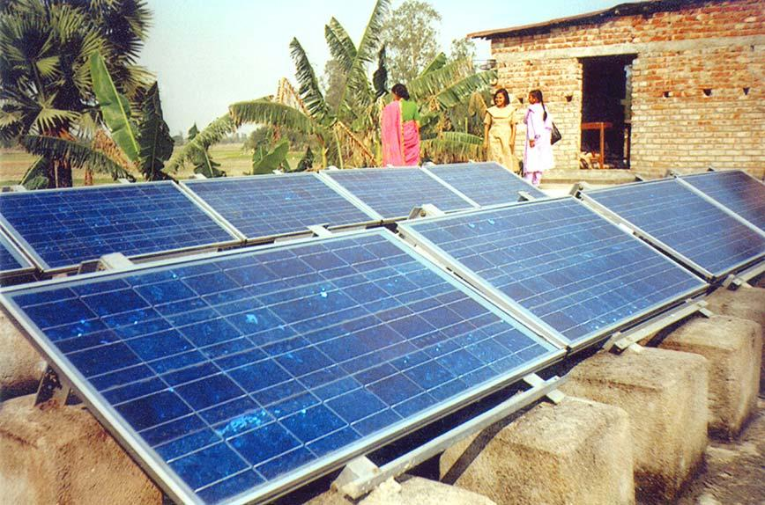

Jamaica - https://www.usaid.gov/jamaica/our-work/caribbean-clean-energy-program

Kazakhstan - Kazahkstan energy company (KEGOC)
https://www.kegoc.kz/ru/press-centr/fotogalereya?page=2
Followed this link: (Power the Future) http://ptfcar.org/en/blog/2018/03/kazakhstan/

Peru - From Peru Ministry of Energy and Mines
https://www.gob.pe/institucion/minem/noticias/19215-instalan-mas-de-80-mil-paneles-solares-en-zonas-rurales-del-peru

Thailand - From pdf - http://usaidcleanpowerasia.aseanenergy.org/download/553/

Vietnam - Image from report cover USAID/NREL:
http://usaidcleanpowerasia.aseanenergy.org/wp-content/uploads/2018/03/SIM-Task1-Report-CoverPage1.jpg

News and Events
http://greeningthegrid.org/news
Title:
Credit: iStock
Source: iStock - grid (NREL)

Help
http://greeningthegrid.org/help

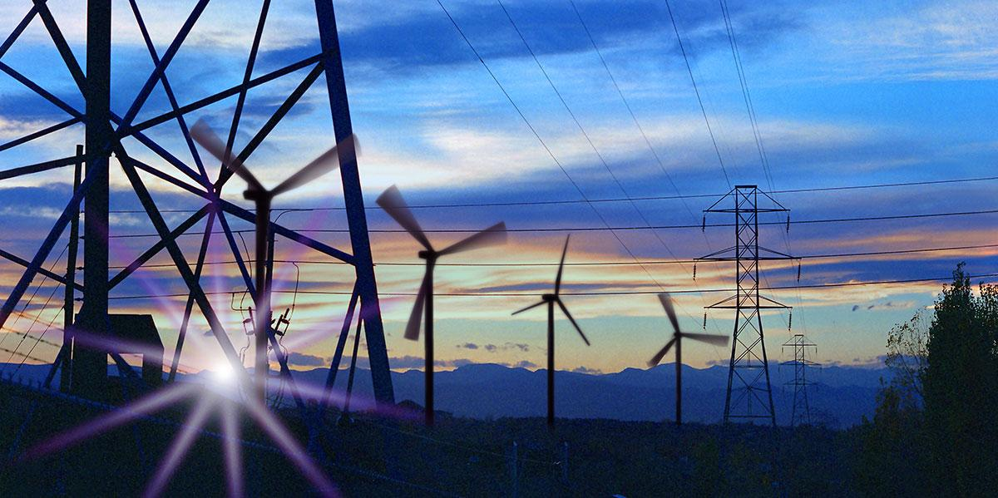
Title:
Credit: iStock
Source: iStock - grid (NREL)

Trainings

https://www.nrel.gov/workingwithus/assets/images/hero-energyexecs-29194.jpg
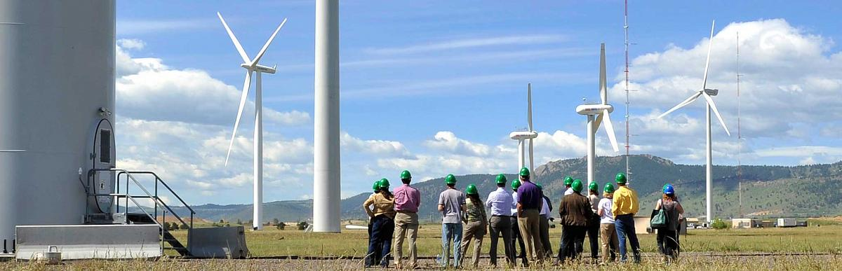

https://www.nrel.gov/news/program/2017/images/wind-plant-tucannon.jpg
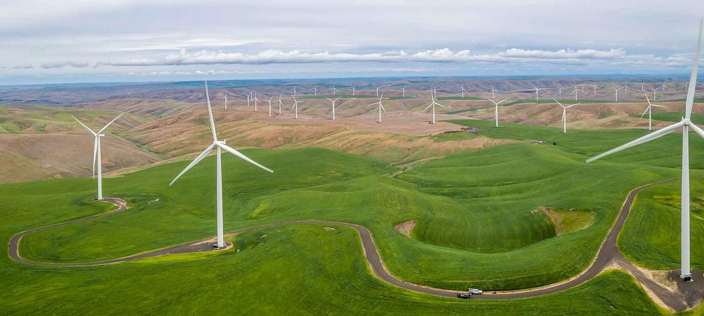
Turbine Inspection (Use next to News on Homepage):
Article: https://www.nrel.gov/news/program/2018/research-turbine-leaves-legacy-in-its-wake.html
Caption: NREL’s Pulitzer Prize-winning staff photographer, Dennis Schroeder, won a photo contest by capturing a blade inspection at the 3-MW GE wind turbine. (Photo by Dennis Schroeder, NREL)

NREL Instagram account: https://www.instagram.com/nationalrenewableenergylab/?hl=en

Resources
http://greeningthegrid.org/resources

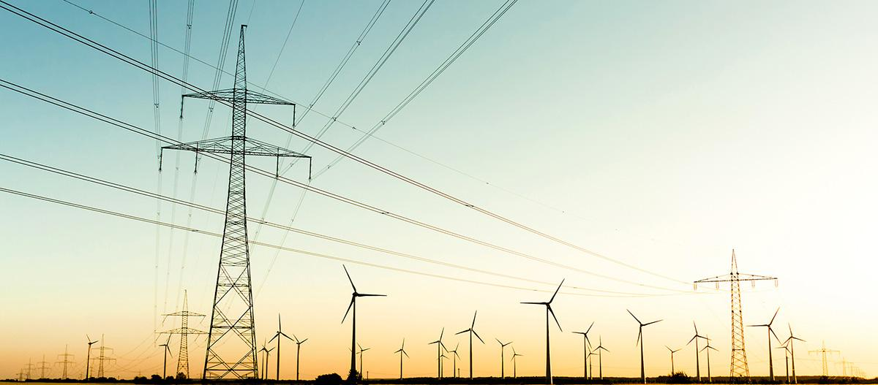

Title: rez-iStock-188076117.jpg
Credit: iStock
Source: Photo provided by client (DropBox)

Toolkits
http://greeningthegrid.org/toolkits

Replace this (already used)
Title:
Credit:
Source:

Toolkits - Child Sites

Grid Integration Toolkit
http://greeningthegrid.org/Grid-Integration-Toolkit

GTG Home
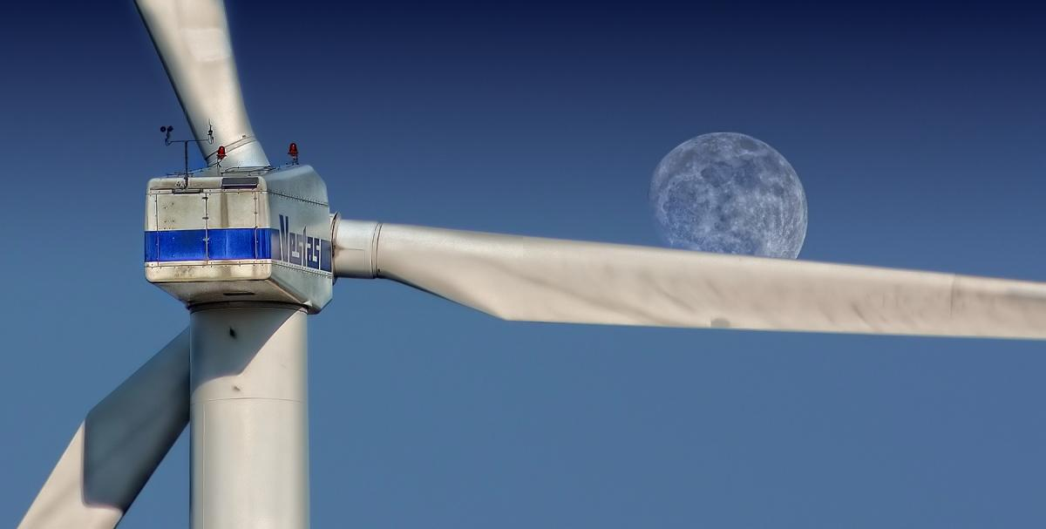
Wind Turbine image - Free photo from Pixabay
https://www.pexels.com/photo/sky-moon-pinwheel-wind-power-33062/

Credit: Wind turbine and moon. Pic: Pixabay.
Source: https://geoharvey.com/2016/08/

GTG Quick Reads
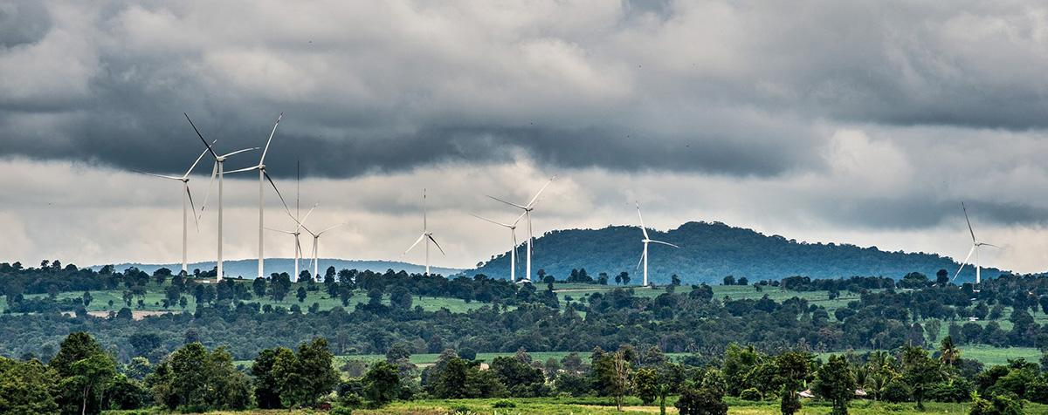
https://geoharvey.files.wordpress.com/2017/12/12-13-chaiyaphum-wind-farm.jpg

Credit: Chaiyaphum Wind Farm
(Image: © Asian Development Bank)
Source: https://geoharvey.com/tag/wind-power/page/4/

GTG Integration Topics
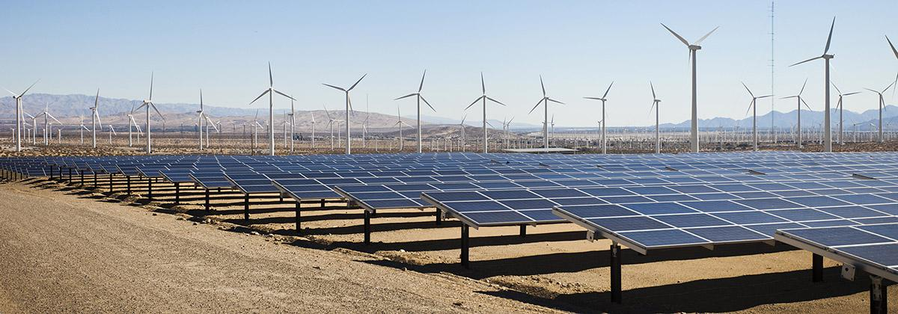
Title:
Credit:
Source: From REZ images in Google drive (Shared with Rose)

GTG Trainings
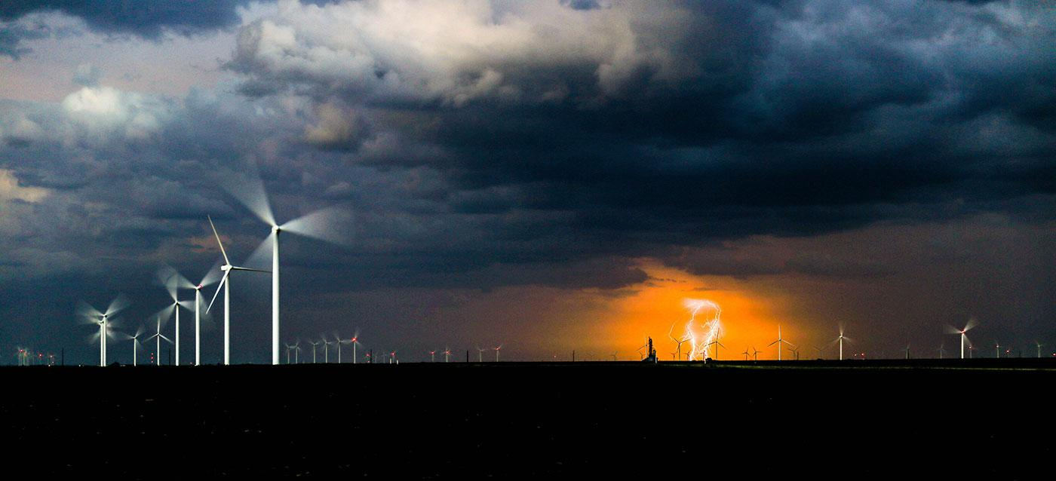
Title: Spring storms in Indiana
Credit: Cassie Boca -
Source: Unsplash https://images.unsplash.com/photo-1495497193089-6284a6fa4c13?ixlib=rb-0.3.5&ixid=eyJhcHBfaWQiOjEyMDd9&s=20ecc331bbd9b93efda8fe6cc2a7efeb&auto=format&fit=crop&w=1998&q=80

GTG Resources
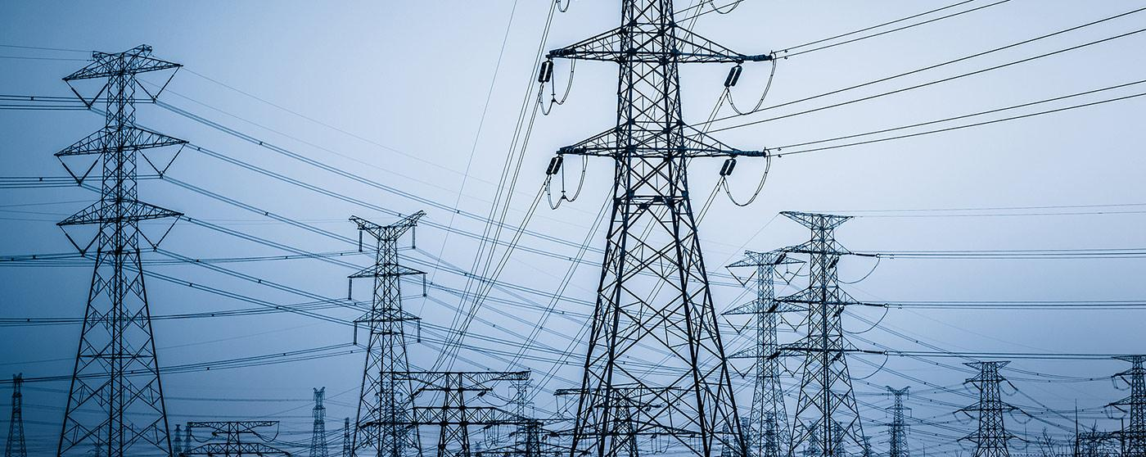
Title: Anypage_REZ-Toolkit_iStock-174433078.jpg
Credit: iStock
Source: From REZ images in Google drive (Shared with Rose)

Distributed Photovoltaics
http://greeningthegrid.org/Distributed-photovoltaics

Home
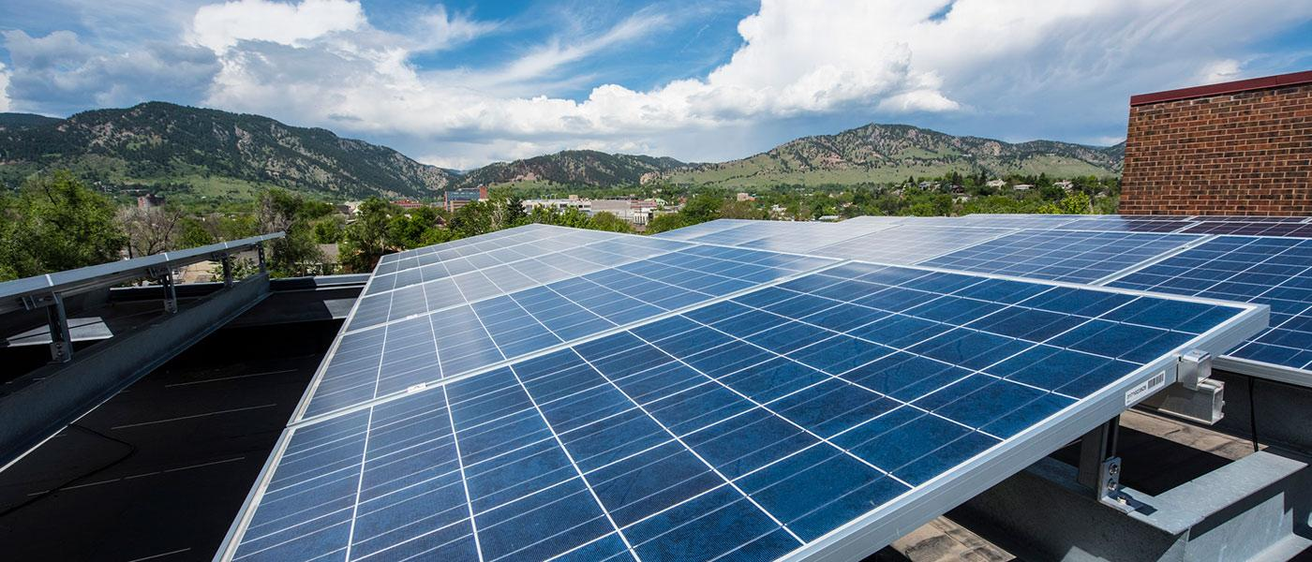

Credit: NREL (from NREL Flickr account)
Title: NREL-34959291910_459e16ae88_k.jpg

DPV - Quick Reads
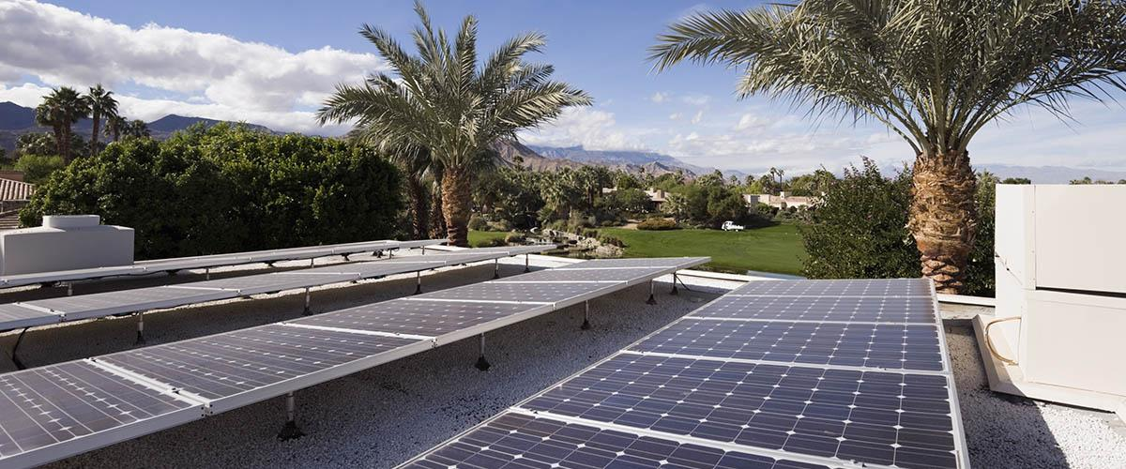

Title: Solar Panels and Palm Trees
Photo Credit: iStock-175249665

DPV - Topics & Resources
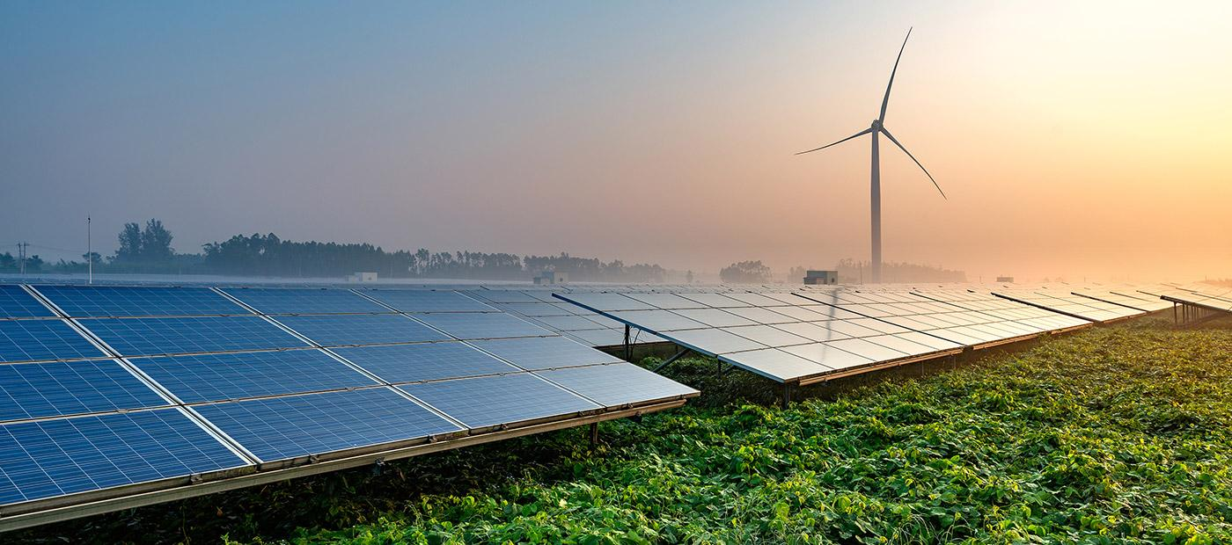
Title: Solar Farms
Credit: iStock-515896988
Source: iStock.com

DPV - Tools & Templates
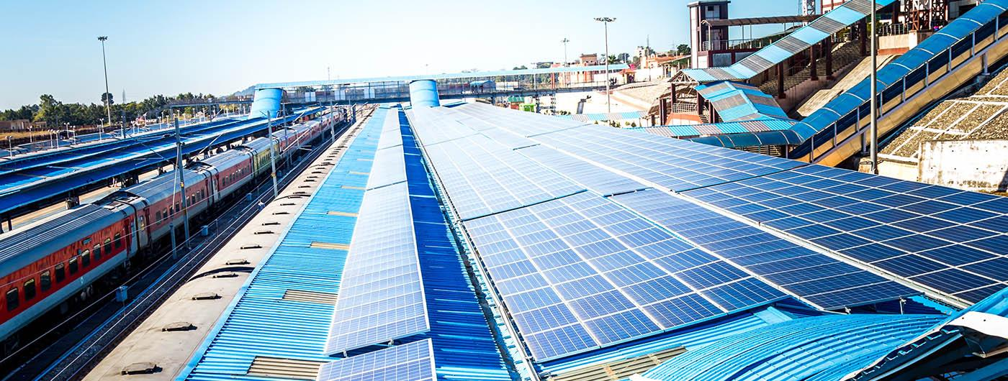

Title: Solar Panel Installation On Rooftop Of Railway Station
Credit: iStock-909155476
Source: iStock.com

DPV Analysis: Overview
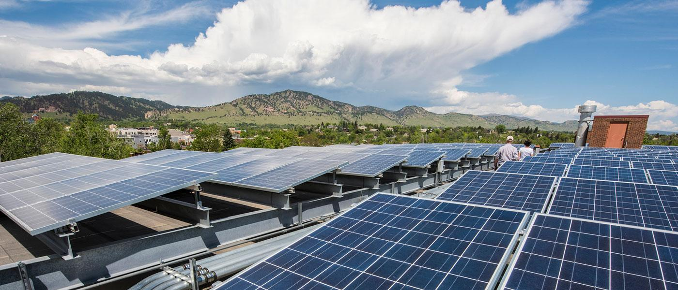
Title: NREL-35216908401_e23cc0a0de_k.jpg
Credit: NREL
Source: From NREL Flickr account

Renewable Energy Zone (REZ) Toolkit
http://greeningthegrid.org/Renewable-Energy-Zones-Toolkit

REZ Toolkit - Home

Title: Power poles and wind turbines in autumn sunlight
Credit: iStock
Source: From REZ photos in Google Drive - https://www.dropbox.com/s/3teck4ch44gs095/1_HOME_REZ%20Toolkit_iStock-188076117.jpg?dl=0

REZ Quick Reads
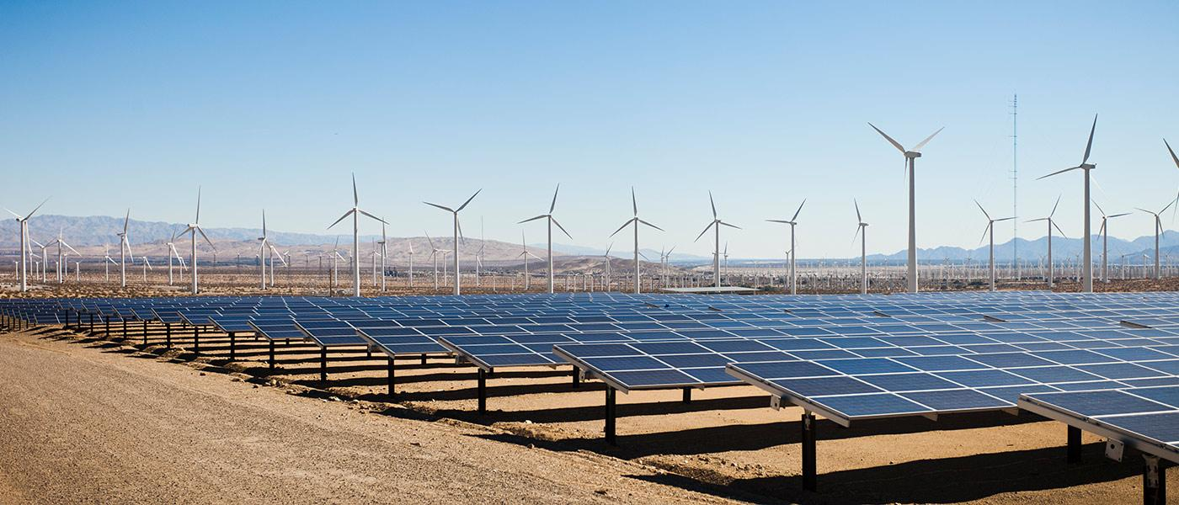
Title: Renewable Energy - Solar and Windmills
Credit: iStock
Source: From REZ photos in Google Drive
https://www.dropbox.com/s/fbom54orsgz03jm/2_QUICK%20READS_REZ%20Toolkit_iStock-155353280.jpg?dl=0

REZ Topics
Title: New Energy On Snow Area Plateau
Credit: iStock
Source: From REZ photos in Google Drive
https://www.dropbox.com/s/uvq8unipf7d718g/3_REZ%20Topics_REZ%20Toolkit_iStock-672741882.jpg?dl=0

REZ Tools & Templates
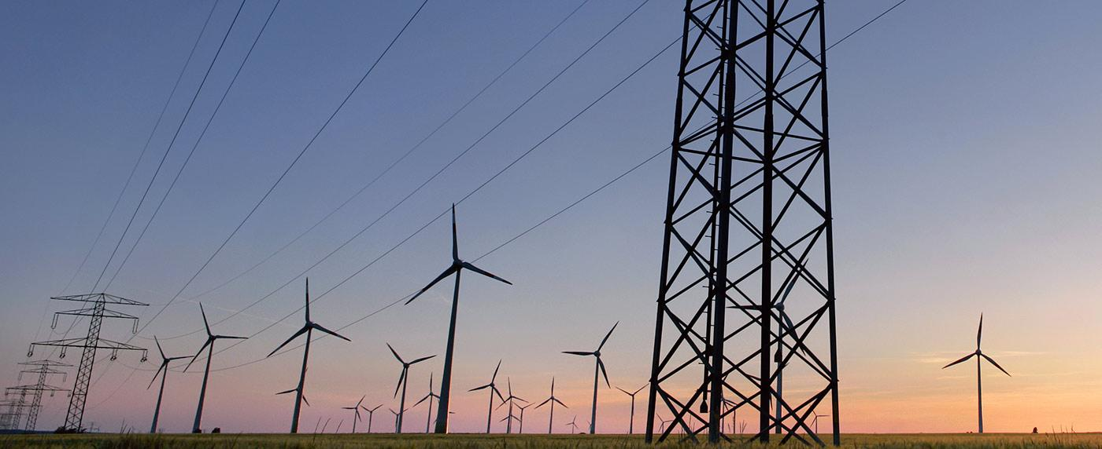
Title: Overhead Power Line In Front Of Wind Turbines
Credit: iStock
Source: From REZ photos in Google Drive
https://www.dropbox.com/s/3vdpkwsvq4us1l5/4_Tools%20and%20Templates_REZ_Toolkit_iStock-522473858.jpg?dl=0

REZ Trainings

Title: Windmills
Credit: iStock
Source: From REZ photos in Google Drive
https://www.dropbox.com/s/p7c7iw71kkrb4jn/5_Trainings_REZ%20Toolkit_iStock-157588110.jpg?dl=0

Saved for possible use
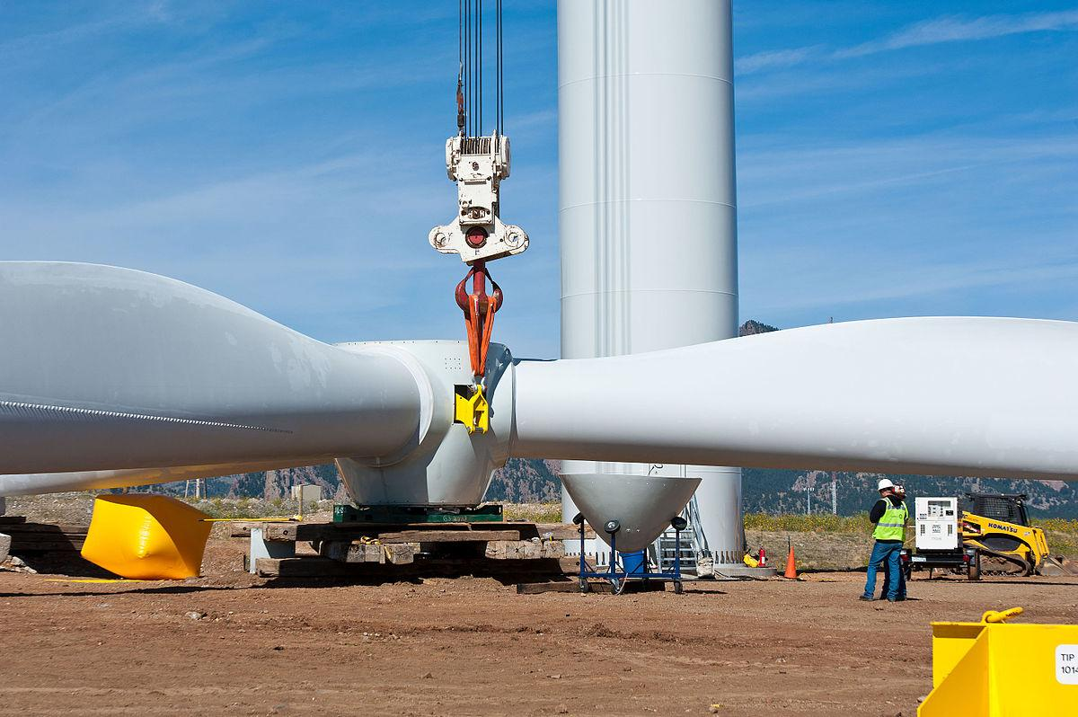

https://geoharvey.files.wordpress.com/2016/12/12-09-workers-installing-a-turbine.jpg

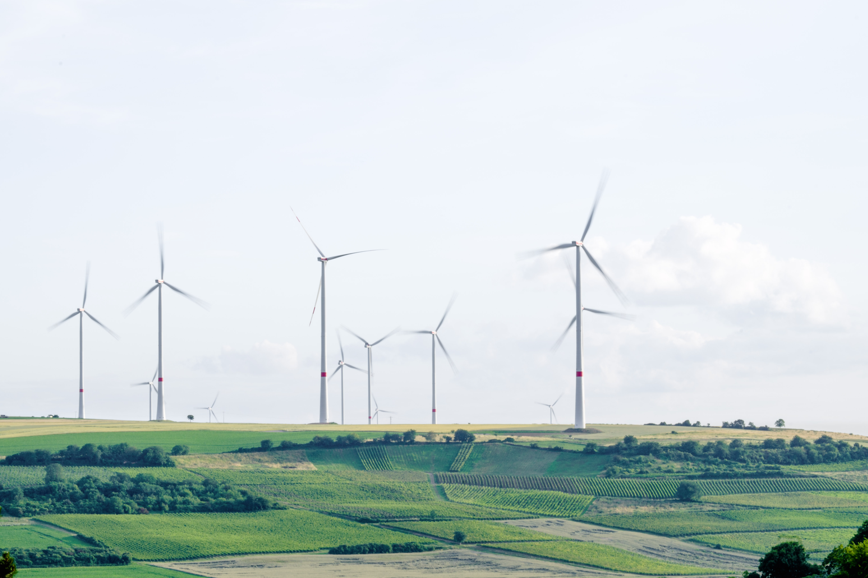
Title:
Credit: Karsten Wurth
Source: Unsplash.com
Karsten-wurth-inf1783-107694-unsplash.jpg
https://unsplash.com/photos/w_a40DuyPAc
Location: Mölsheim, Germany

Johanna-montoya-483038-unsplash.jpg

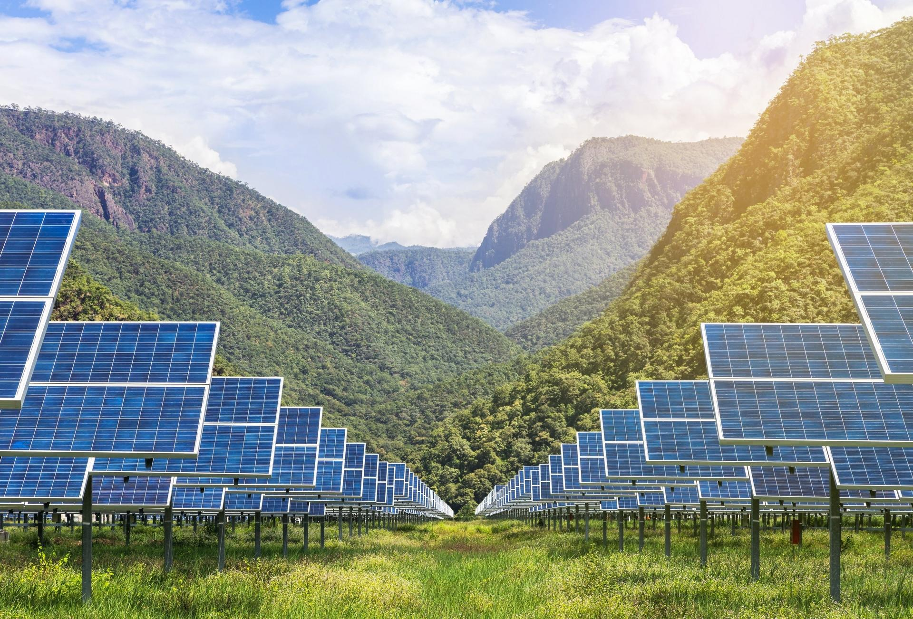
http://www.greenenergytimes.org/wp-content/uploads/2017/06/06-18-Solar-array-thinkstock-image.jpg

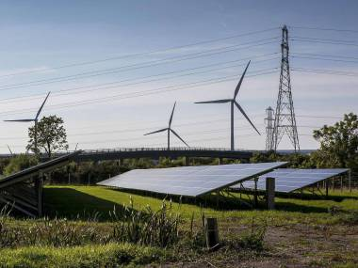
UK Renewables (Getty Images)
https://geoharvey.com/2018/02/21/february-21-energy-news-6/

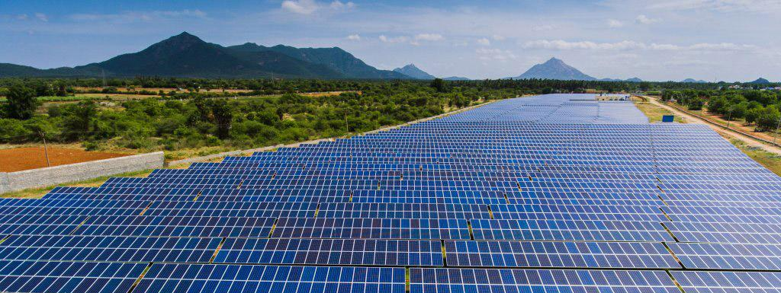
https://geoharvey.files.wordpress.com/2018/02/02-13-siemens-gamesa-solar-array.jpg

Credit: Siemens Gamesa solar array (Siemens Gamesa image)
Source: https://geoharvey.com/2018/02/

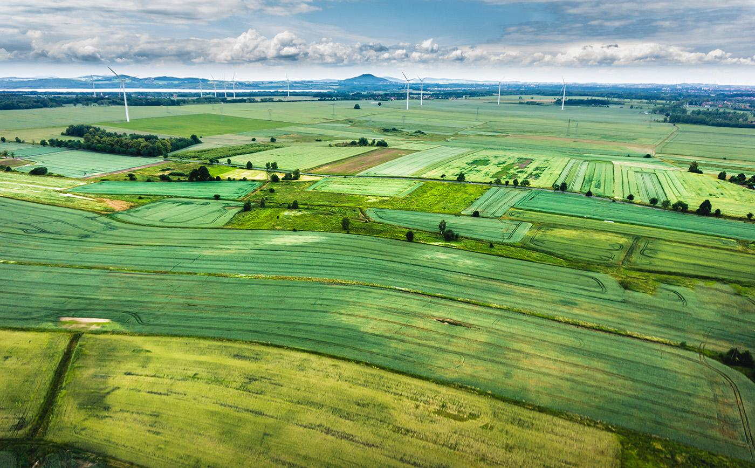
Credit: Tomasz Bazylinski
Source: UnSplash

